SEWAGE MANAGEMENT PLAN
NAVIG8 GALLANTRY
IMO No: 9712876

In accordance with Regulations for the
Prevention of Pollution by
Sewage from Ships – Marpol Annex IV

CONTENTS
1) Ship’s Particulars
2) Sewage Discharge Criteria
3) Maximum Sewage Discharge Rate (Greater than 12 nautical miles)
4) Sewage Treatment Piping Diagram
5) Sewage Discharge Record Sheet

Section 1) SHIP PARTICULARS

Ship’s Name: NAVIG8 GALLANTRY
Flag: MARSHALL ISLANDS
Call Sign: V7HH2
IMO Number: 9712876
Ship Type: OIL TANKER
Length Overall: 249.9 m
Moulded Breadth: 44.0 m
Gross Tonnage: 63965
Net Tonnage: 32874
Summer Draft: 14.732 m
Summer Freeboard: 6.79 m
Summer Displacement: 131,000 t
Summer Deadweight: 109,999 t

Section 2) Sewage Discharge Criteria
The discharge of sewage into the sea is prohibited, except when;
The ship is discharging comminuted and disinfected sewage using a system approved by the Administration at a distance of more than 3 nautical miles from the nearest land
OR
Sewage which is NOT comminuted or disinfected, at a distance of more than 12 nautical miles from the nearest land, provided that in any case, the sewage that has been stored in holding tanks shall not be discharge instantaneously but at a moderate rate when the ship is en route and proceeding at not less than 4 knots; the rate of discharge shall be approved by the Administration based upon standards developed by the Organization;
OR
The ship has in operation an approved sewage treatment plant which has been certified by the Administration,
AND
Additionally, the effluent shall not produce visible floating solids nor cause discoloration of the surrounding water.
The above provisions shall not apply to ship operating in the waters under the jurisdiction of a State and visiting ships from other States while they are in these waters and are discharging sewage in accordance with such less stringent requirement as may be imposed by such State.
Section 3) Maximum untreated sewage discharge rate (Greater than 12 nautical miles)
The discharge of untreated sewage is prohibited except for emergency case as per DNV CLEAN NOTATION. In this respect, in emergency cases where untreated sewage is discharged to sea the records shall include information on the ships speed and distance to nearest to shore at the time of sewage discharge.
The maximum permissible discharge rate is 1/200,000 (or one 200,00th part) of swept volume as follows:
DR_{max} = 0.00926 x V x D x B
Where:
DR_{max}: Maximum permissible discharge rate (m3/h)
V: Ship’s average speed (knots) over the period
D: Draft (m)
B: Breadth (m)
The maximum permissible discharge rate specified above refers to the average rate as calculated over any 24 hour – period, or the period of discharge if that is less, and may be exceed by no more than 20% when measured on an hourly basis.
Approval of rate by administration
The administration should approve the rate of discharge above specified above based upon the ship’s maximum summer draft and maximum service speed. Where sewage is to be discharged at a different combination of draft and speed one or more secondary discharge rates may also be approved.
Method of calculation
- The calculated swept volume of the ship is to be determined for drafts up to and including the summer draft.
- Where a ship is to discharge sewage from a holding tank using a pump calibrated at a fixed rate, the pump can be either be:
- Calibrated at a the rate permitted at 4 knots; or
- Calibrated for a specific minimum ship’s speed in excess of 4 knots.
- Where the intended actual discharge rate exceeds that permissible at 4 knots the actual discharge rate may need to be reduced or the speed increased. The rate and speed is to be detailed in the approval issue by the Administration.
Compliance with the rate
Before undertaking a sewage discharge in accordance with this standard, the crew member responsible for sewage operations should ensure that the ship is en route, is more than 12 nautical miles from the nearest land and the navigation speed is consistent with the discharge rate that has been approved by the Administration. Ships with high discharge requirements are encouraged to keep notes of calculations of the actual discharges to demonstrate compliance with the approved rate.
MAXIMUM RATE OF DISCHARGE OF UNTREATED SEWAGE IN ACCORDANCE WITH RESOLUTION MEPC.157(55)
SHIP NAME : NAVIG8 GALLANTRY
IMO No. : 9712876
CLASS No. : -
BREADTH : 44 M
MAX. SUMMER DRAFT : 14.7M
MAX, SERVICE SPEED : 15 KNOTS
The maximum permissible discharge rate refers to the average rate as calculated over any 24 hour period, or the period of discharge if that is less, and may be exceeded by no more than 20% when measured on an hourly basis.
NOTE : The permissible rate of discharge is reduced at reduced draft and/or speed. Tabular discharge rate is as follows.
TABULAR DISCHARGE RATE(㎥/h)
Speed | 4 | 5 | 6 | 7 | 8 | 9 | 10 | 11 | 12 | 13 | 14 | 15
Draft
7 | 11.41 | 14.26 | 17.11 | 19.96 | 22.82 | 25.67 | 28.52 | 31.37 | 34.22 | 37.08 | 39.93 | 42.78
8 | 13.04 | 16.30 | 19.56 | 22.82 | 26.08 | 29.34 | 32.60 | 35.85 | 39.11 | 42.37 | 45.63 | 48.89
9 | 14.67 | 18.33 | 22.00 | 25.67 | 29.34 | 33.00 | 36.67 | 40.34 | 44.00 | 47.67 | 51.34 | 55.00
10 | 16.30 | 20.37 | 24.45 | 28.52 | 32.60 | 36.67 | 40.74 | 44.82 | 48.89 | 52.97 | 57.04 | 61.12
11 | 17.93 | 22.41 | 26.89 | 31.37 | 35.85 | 40.34 | 44.82 | 49.30 | 53.78 | 58.26 | 62.75 | 67.23
12 | 19.56 | 24.45 | 29.34 | 34.22 | 39.11 | 44.00 | 48.89 | 53.78 | 58.67 | 63.56 | 68.45 | 73.34
13 | 21.19 | 26.48 | 31.78 | 37.08 | 42.37 | 47.67 | 52.97 | 58.26 | 63.56 | 68.86 | 74.15 | 79.45
14 | 22.82 | 28.52 | 34.22 | 39.93 | 45.63 | 51.34 | 57.04 | 62.75 | 68.45 | 74.15 | 79.86 | 85.56
15 | 24.45 | 30.56 | 36.67 | 42.78 | 48.89 | 55.00 | 61.12 | 67.23 | 73.34 | 79.45 | 85.56 | 91.67

Section 4) SEWAGE TREATMENT PIPING DIAGRAM
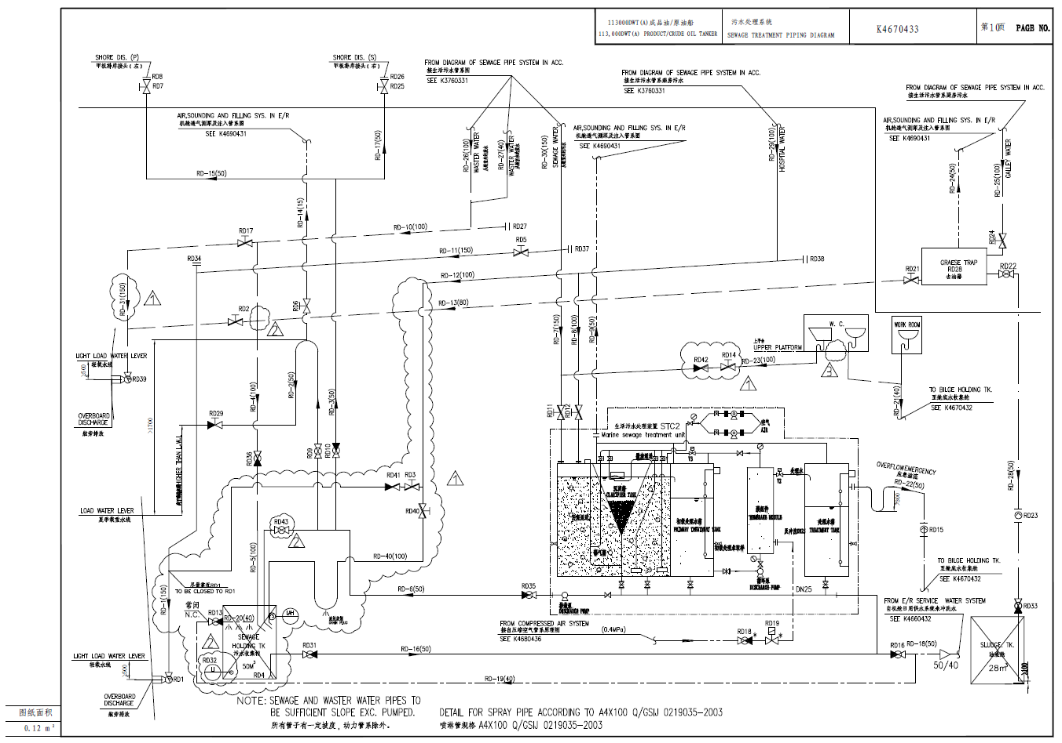
Section 5) Sewage Discharge Record Sheet
Records of discharge are to be maintained in the format below
